Test No. | What I am Testing | Reason for Choice | Test Data | Type | Expected Outcome | Actual Outcome | Comment
1 | Hyperlink from Home page to Tours page | To check if it goes to the right page | Home page hyperlink to Tours page | Navigation | It will go to the Tours page | The link goes to the Tours page | Success.
2 | Hyperlink from Home page to Our Staff page | To check if it goes to the right page | Home page hyperlink to Our Staff page | Navigation | It will go to the Our Staff page | The link goes to the Our Staff page | Success.
3 | Hyperlink from Our Staff to the Coach Drivers page | To check if it goes to the right page | Our Staff hyperlink to Coach Drivers page | Navigation | It will go to the Coach Drivers page | The link goes to the Coach Drivers page | Success.
4 | Hyperlink from Tours page to Cotswolds Theme Park page | To check if it goes to the right page | Tours page hyperlink to Cotswolds Theme Park page | Navigation | It will go to the Cotswolds Theme Park page | The link goes to the Cotswolds Theme Park page | Success.
5 | Return link from Tours page to home page | To check if it goes to the right page | Tours page hyperlink back to home page | Navigation | It will go back to the Home page | The link goes back to the Home page | Success.
6 | Return link from Cotswolds Scorpion Theme Park page to Tours page | To check if it goes to the right page | Cotswolds Scorpion Theme Park page back to Tours page | Navigation | It will go back to the Tours page | The link goes back to the Tours page | Success.
7 | Return link from Our Staff page to Home page | To check if it goes to the right page | Our Staff page back to Home page | Navigation | It will go back to Home page | The link goes back to the Home page | Success.
8 | Return link from Coach Drivers page to Our Staff page | To check if it goes the right page | Coach Drivers page to Our Staff page | Navigation | It will go back to Our Staff page | The link goes back to the Our Staff page | Success.

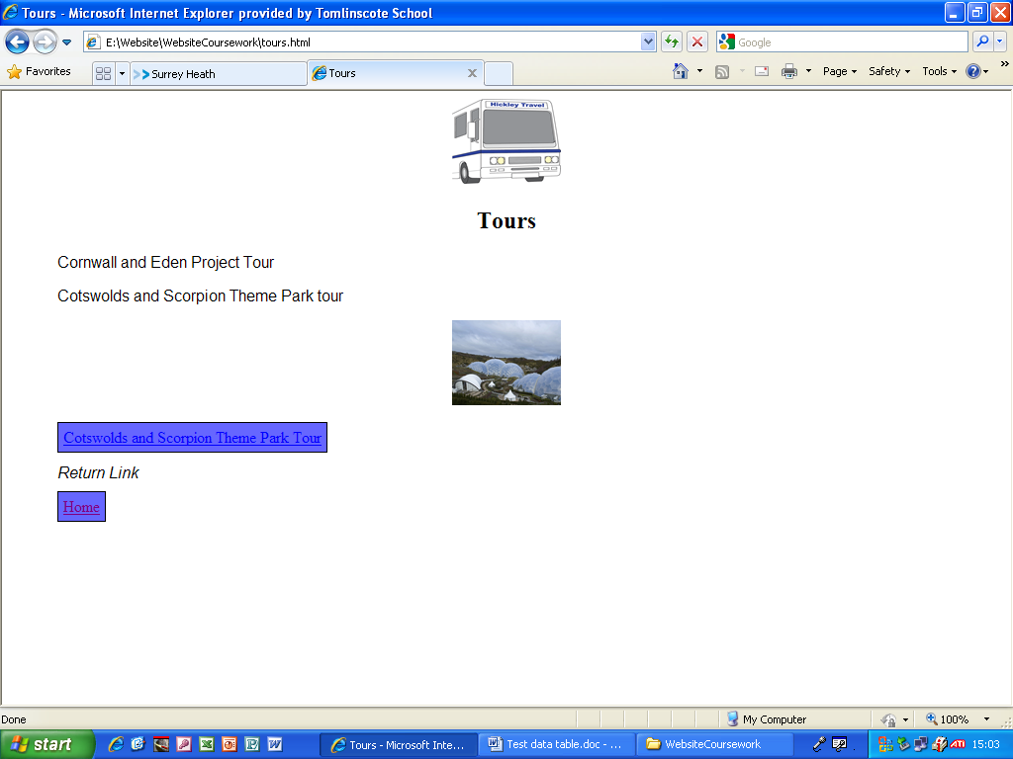
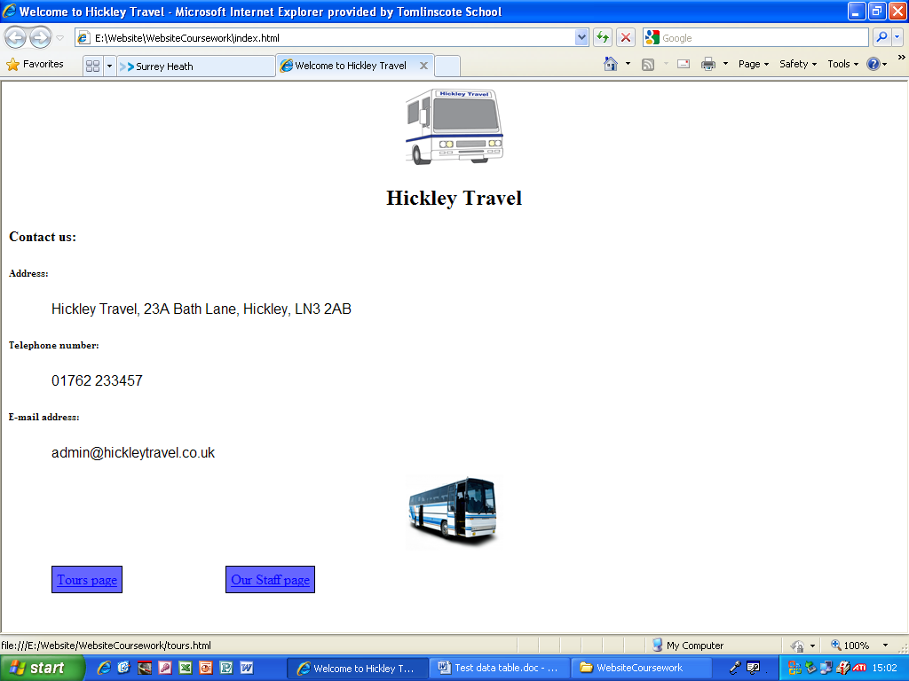
This is the home page and these screenshots show that the circled link goes to the Tours page.

This is the Tours page and these screenshots show that the circled link goes to the Cotswolds and Scorpion Theme Park page.
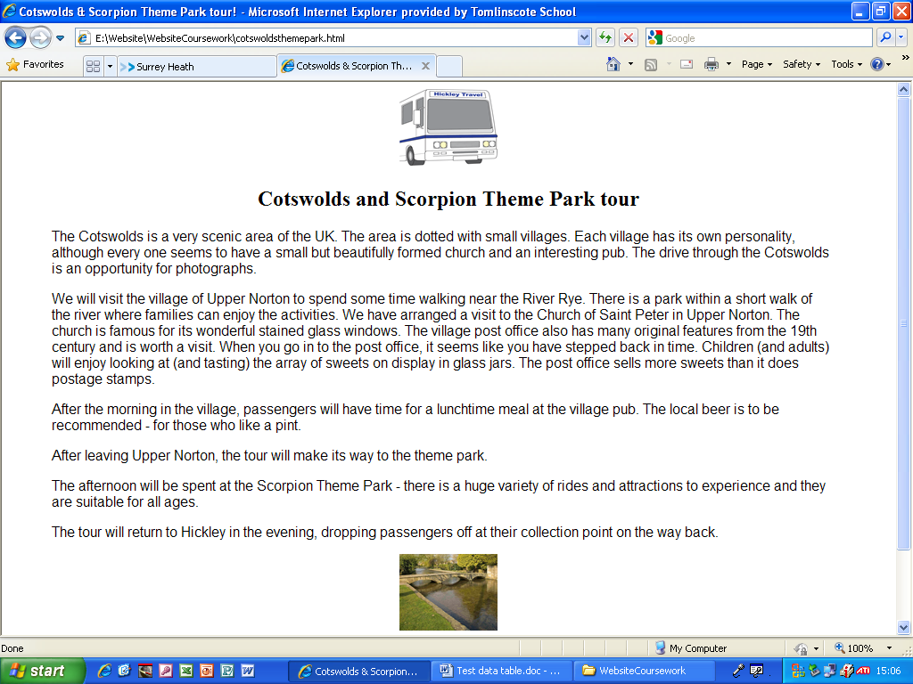
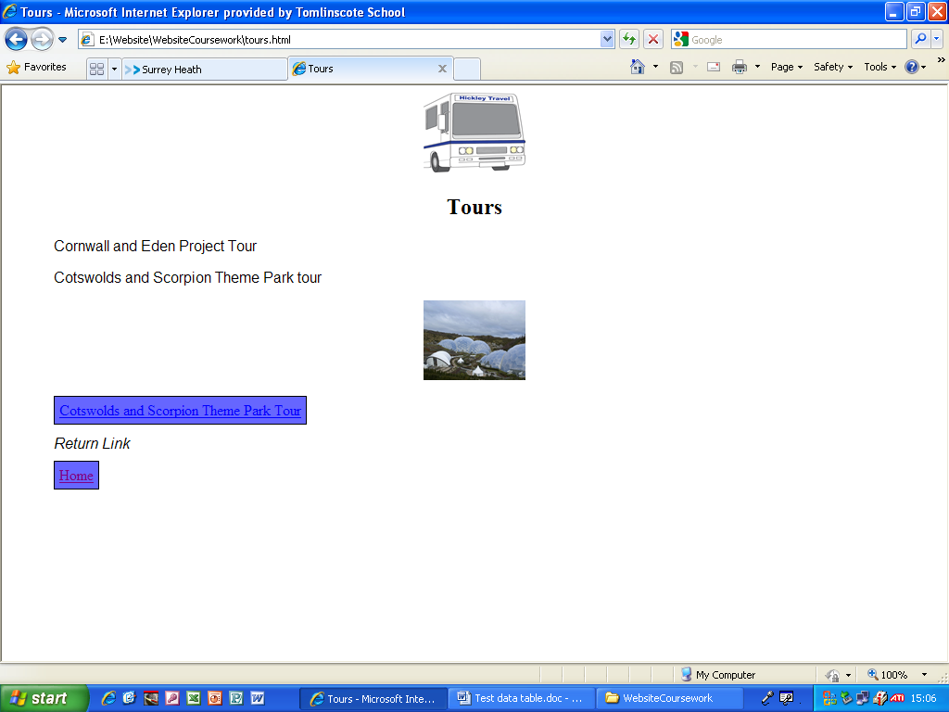
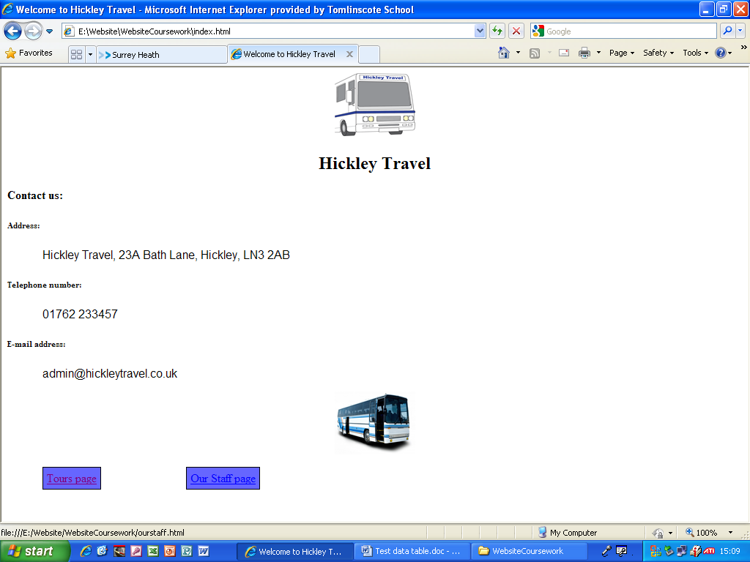
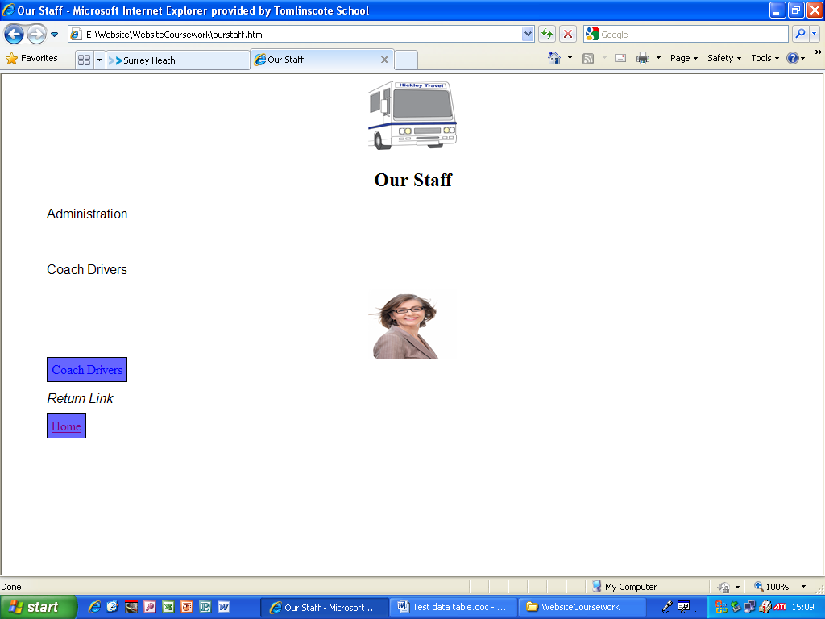
This is the Home page and these screenshots show that the circled link goes to the Our Staff page.

This is the Our Staff page and these screenshots show that the circled link goes to the Coach Drivers page.
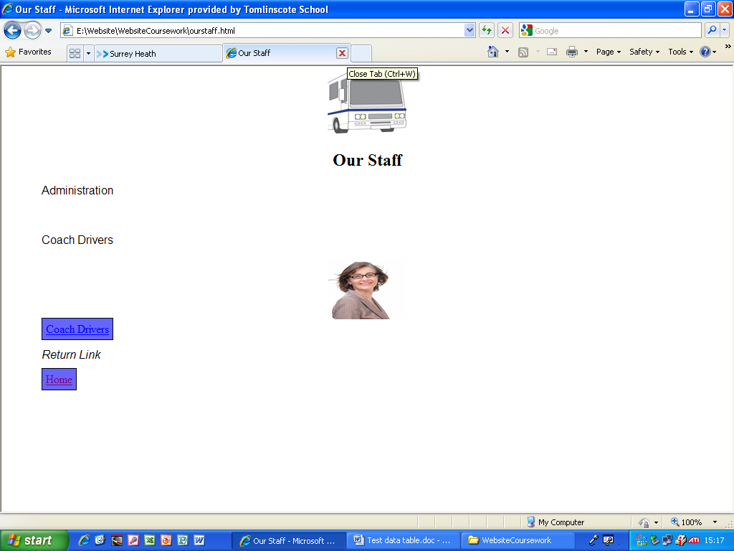
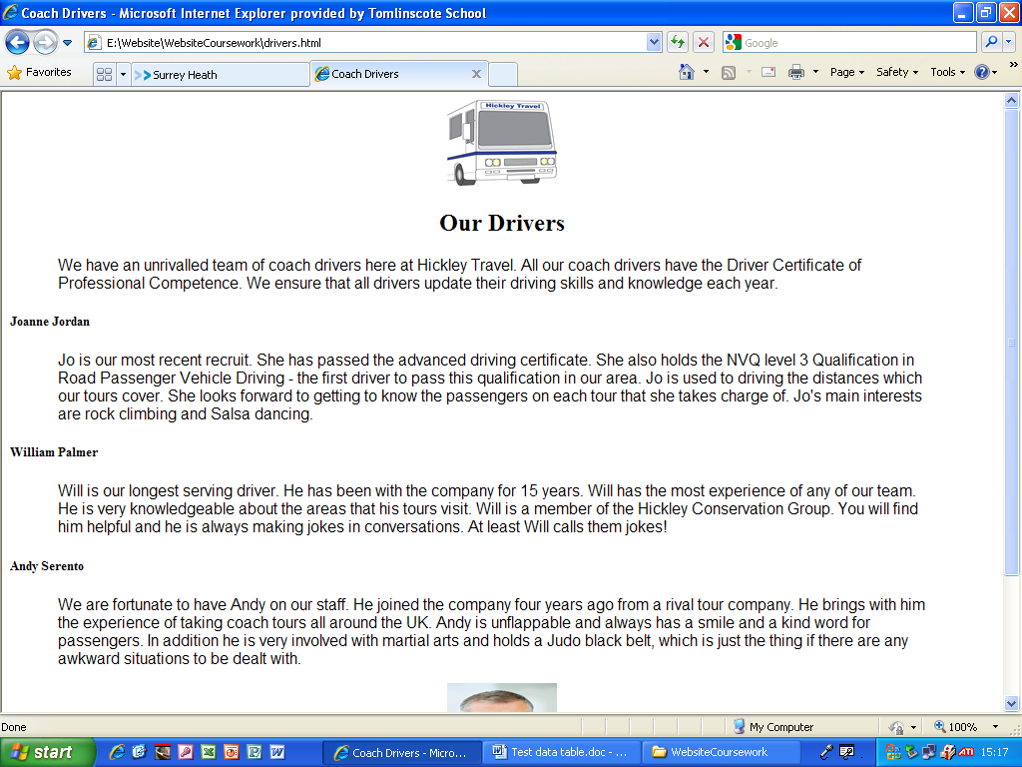

This is the Coach Drivers page and these screenshots show that the circled link goes back to the Our Staff page.

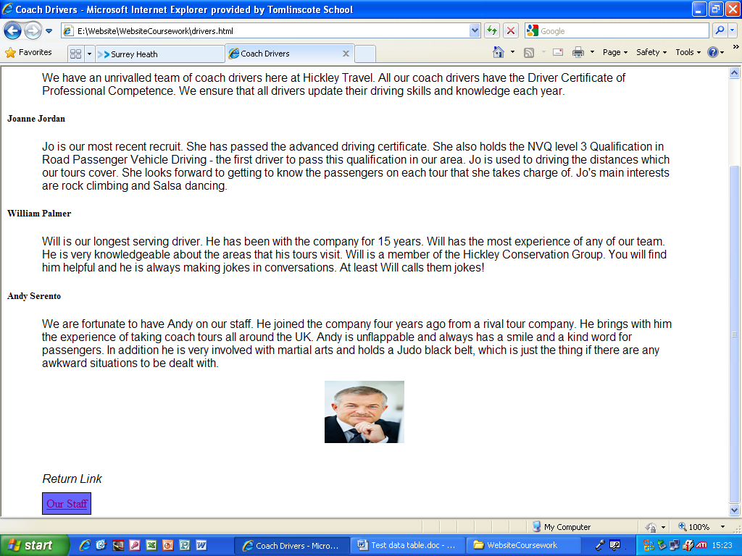
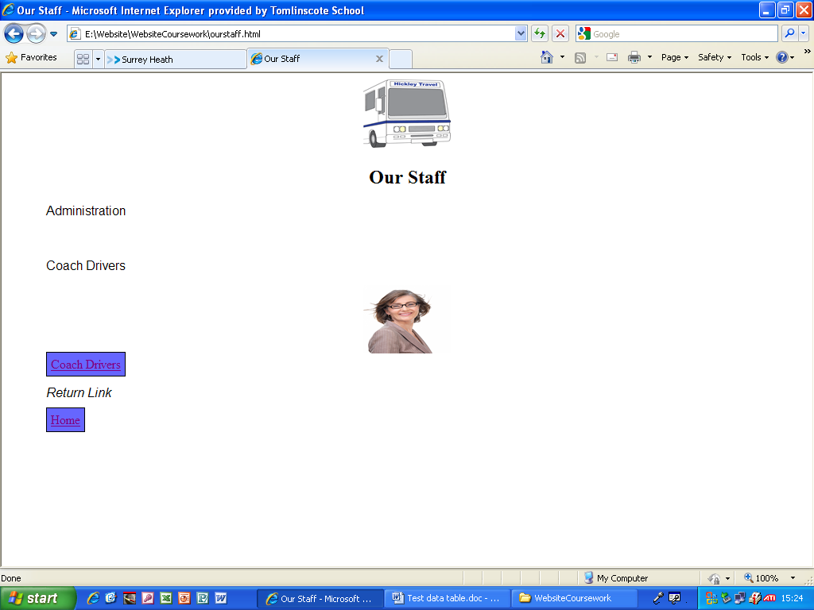

This is the Our Staff page and these screenshots show that the circled link goes back to the Home page.

